Planning I-CBBG 2025

1/27/23

# 1. This is a draft

This is a working document for the planning of ICBBG 2025. Nothing in the document is set into stone. This will serve as a reference in our first meeting.

Your comments and suggestions are appreciated.

# 2. Schedule

## Day 1

|  |  |
| --- | --- |
| 9:00 – 17:00 | workshops |
| 18:00 – 20:00 | Icebreaker reception |

## 2.1 Day 2

* **6 keynotes + 36 paper presentations**

|  |  |  |  |
| --- | --- | --- | --- |
| 8:00 | opening & registration |  |  |
| 8:30 | plenary session 1 |  |  |
|  | 3 x 30 minute presentation |  |  |
| 10:00 | coffee break |  |  |
| 10:30 | session 2a | session 2b | session 2c |
|  | 6 x 15 min | 6 x 15 min | 6 x 15 min |
| 12:00 | lunchbreak + poster session |  |  |
| 13:30 | session 3a | session 3b | session 3c |
|  | 6 x 15 min | 6 x 15 min | 6 x 15 min |
| 15:00 | coffee break |  |  |
| 15:30 | plenary session 4 |  |  |
|  | 3 x 30 minute presentation |  |  |
| 17:00 | end of sessions |  |  |
| 18:00 | conference dinner |  |  |
| 20:00 | end of day 1 |  |  |

## 2.2 Day 3

* **6 keynotes/debates + 36 paper presentations**

| 8:00 | opening & registration |  |  |
| --- | --- | --- | --- |
| 8:30 | plenary session 5 |  |  |
|  | 3 x 30 min |  |  |
| 10:00 | coffee break |  |  |
| 10:30 | session 6a | session 6b | session 6c |
|  | 6 x 15 min | 6 x 15 min | 6 x 15 min |
| 12:00 | lunchbreak + poster session |  |  |
| 13:30 | session 7a | session 7b | session 7c |
|  | 6 x 15 min | 6 x 15 min | 6 x 15 min |
| 15:00 | coffee break |  |  |
| 15:30 | plenary session 8 |  |  |
|  | 3 x 30 min |  |  |
| 17:00 | end of conference |  |  |

## 2.3 Day 4

* **Field trips**

|  |
| --- |
| Note |
| * Based on this original plan, there will be 12 plenary talks, 72 presentations in parallel sessions, and a number of poster presentations in 2 poster sessions. * We may want to reduce the number of plenary talks to make room for more parallel sessions. * We can have at least three tracks:   + Bio-mediated Geotechnics   + Bio-inspired Geotechnics   + Education, training, industrial collaboration, sustainability in Biogeotechnics * For each track, we can have a few sessions targeting on different applications such as:   + Bio-mediated     - Hazard mitigation     - Construction     - Environmental remediation or restoration   + Bio-inspired     - Site investigation     - Foundation     - Cross-cutting   + ETCS (successes and pitfalls)     - Education     - Training     - Industrial collaborations     - Sustainability |

# 3. Important Dates

| Event | Date |
| --- | --- |
| Session Proposals Due | April 2023 |
| Abstract Submissions Begin | June 2023 |
| Abstracts Due | October 2023 |
| Full Paper Invitations Begin | December 2023 |
| Draft Full Papers due | May 2024 |
| Final Full papers due | December 2024 |
| I-CBBG 2025 | May 18-21, 2025 |

# 4. Committees

* Leon van Paassen
* Julian Tao
* Ed Kavazanjian
* Hamed Khodadadi Tirkolaei
* Claudia Zapata
* Paola Bandini
* Jason DeJong
* David Frost
* All other Senior investigators at CBBG
* CBBG IDEA team

## 4.1 Scientific advisory board

* To be announced

|  |
| --- |
| Note |
| After discussing with Ed, may be a better arrangement is:   * Co-chairs   + Edward Kavazanjian   + Susan Burns * Core organising committee (from partner campuses)   + Julian Tao   + Alejandro Martinez   + Douglas Cortes   + Sheng Dai * Other organising committee members   + junior investigators of the partner universities   + experts outside of CBBG: e.g., Brina, Mike, Nariman * Scientific Advisory boards   + CBBG leadership team   + Select members in the SAB and IAB of CBBG   + International experts |

# 5. Announcements

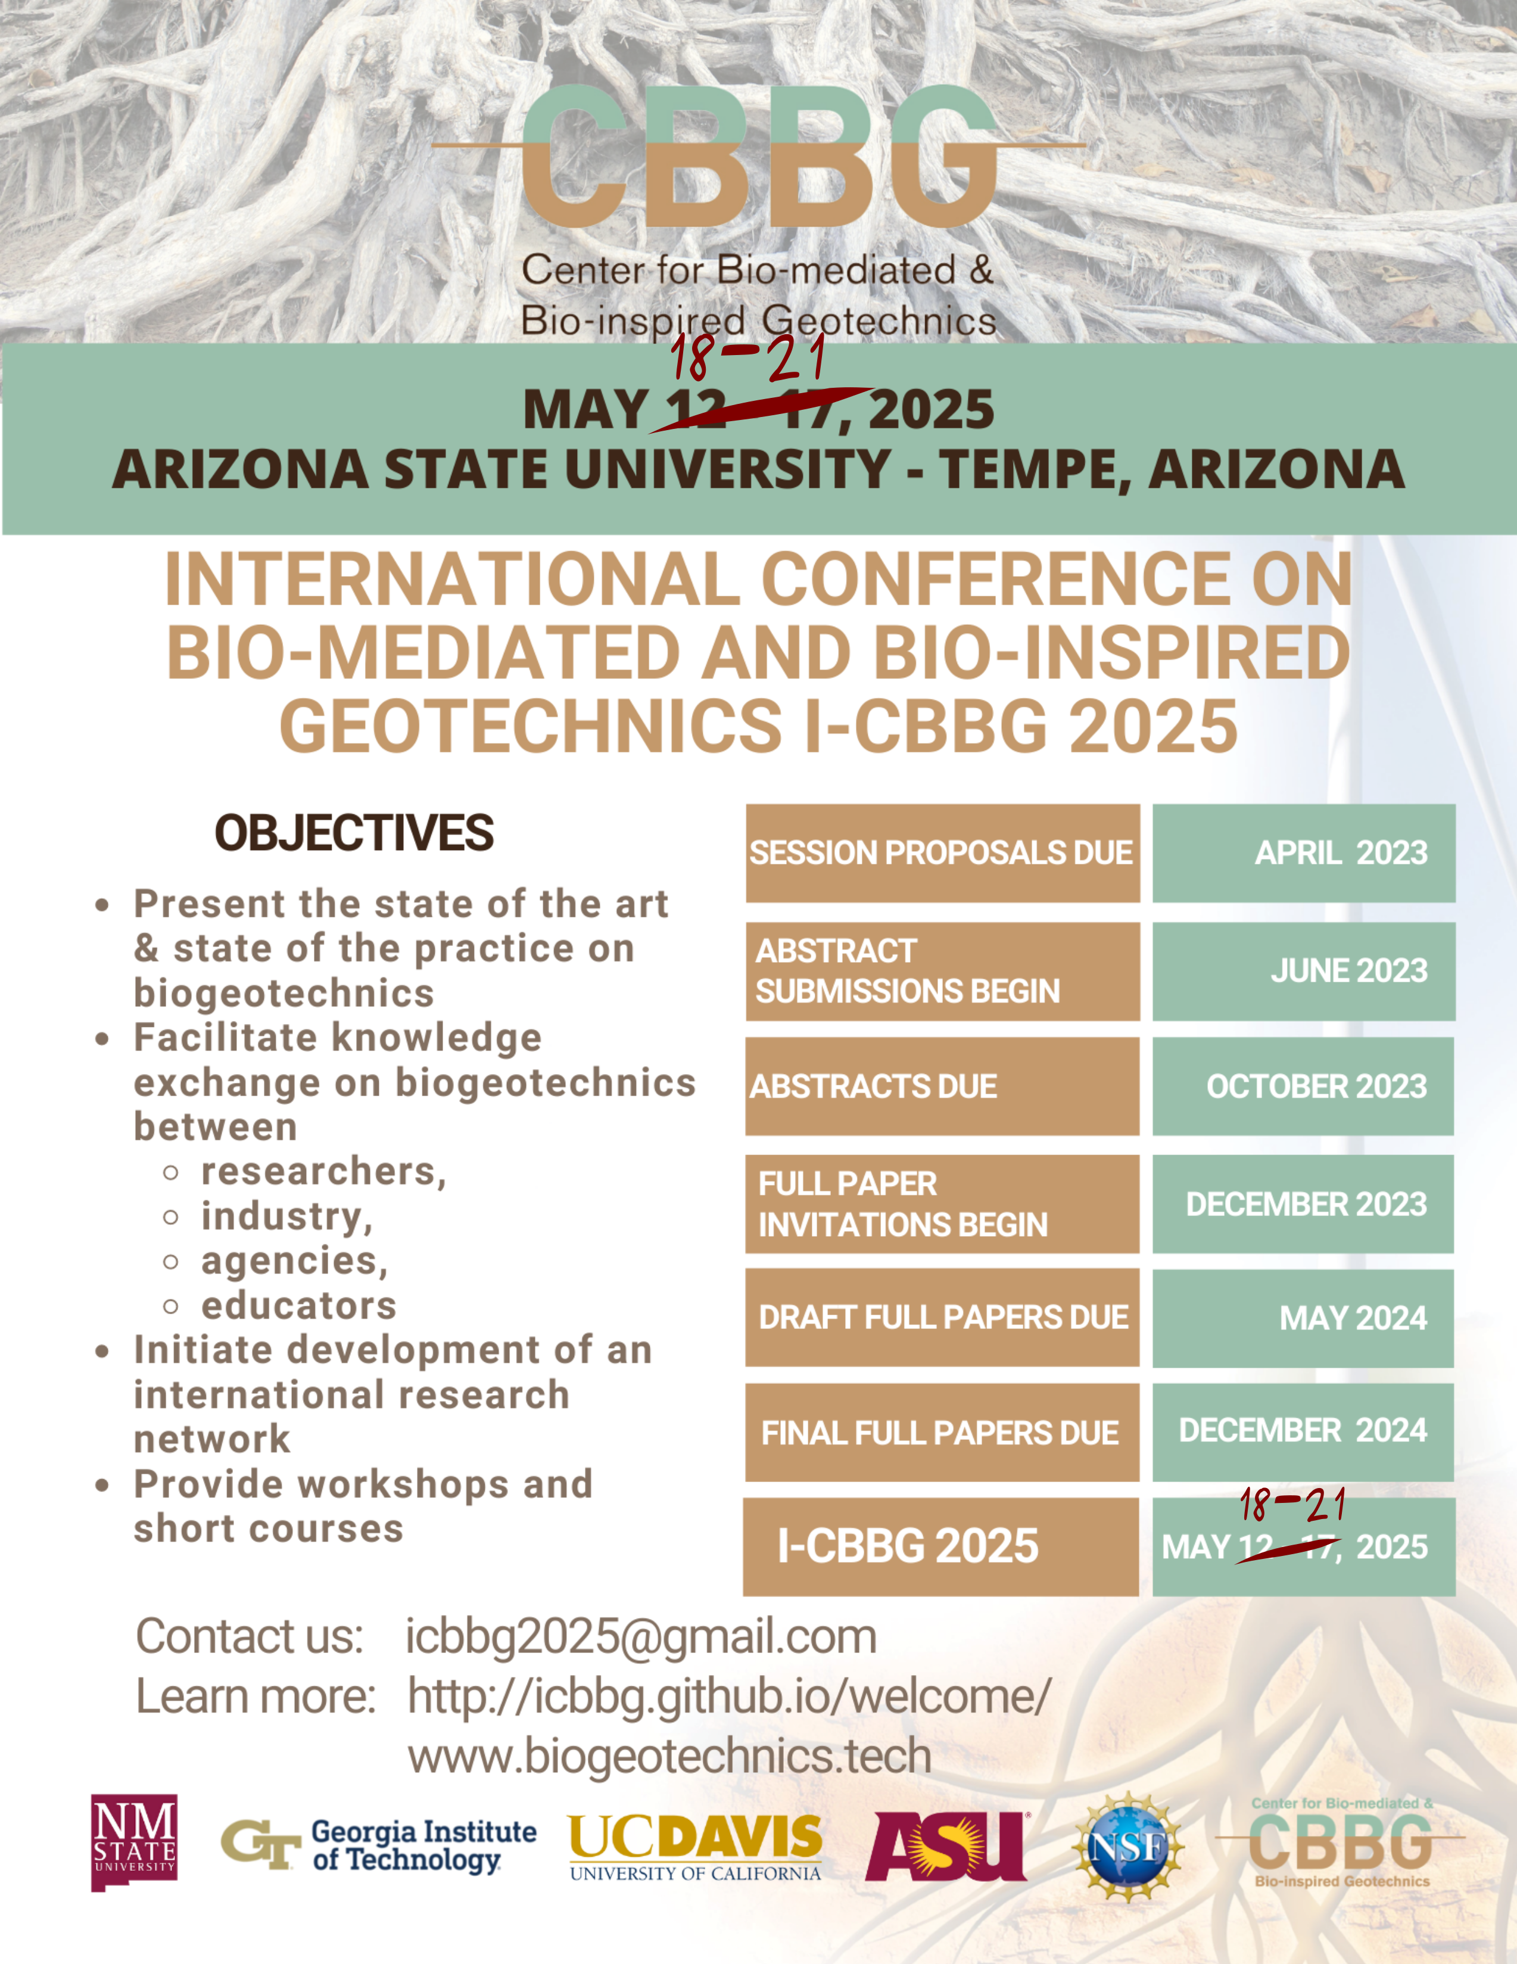

## 5.1 Call for Sessions

|  |
| --- |
| Note |
| Do we really need a call for sessions? |

* TBD

## 5.2 Call for Abstracts

* TBD

## 5.3 Call for Papers

# 6. Speakers

|  |
| --- |
| Note |
| To be announced |

# 7. Venue

[**Memorial Union**](https://eoss.asu.edu/mu) at ASU campus

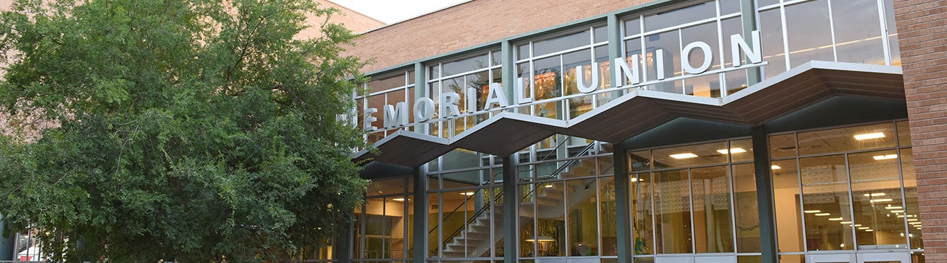

[MU Map](https://eoss.asu.edu/sites/default/files/MU-buildingMap.pdf)

## 7.1 Lodging

[**The Westin Tempe**](https://www.marriott.com/hotels/travel/phxwt-the-westin-tempe/)

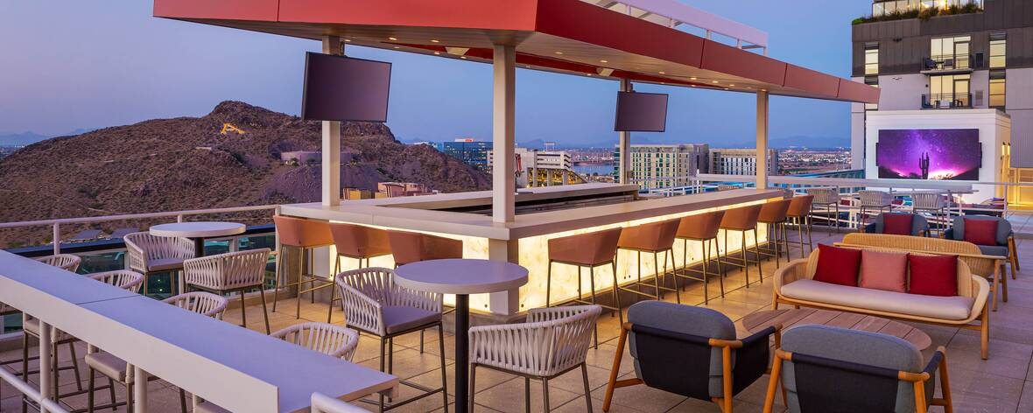

|  |
| --- |
| Note |
| * Originally planned for:   + 150 -400 attendees   + Up to 200 in-person; up to 200 online * We may need to select an off-campus venue, such as the new Omni hotel |

# 8. Registration

|  |
| --- |
| Note |
| More details to come |

* Abstract
* Oral/poster presentation
* Paper in peer-reviewed proceedings (or journal special issue)
* Link to zoom access to video conference
* Proceedings

## 8.1 In person attendance includes

* All of above
* 4 coffee breaks
* 1 x ice breaker
* 2 x lunch
* 1 x conference dinner

## 8.2 Extra activities

* In person short courses, include lunch and coffee breaks)
* Excursion (Frank Loyd Wright)
* (Engineering) Geology excursion (2 days, including 1 overnight stay in Flagstaff)
* Golf clinic with Ed

|  |
| --- |
| Note |
| * Do we still need the virtual option? * We need a platform for registration * Do we still need the extra activities? |

# 9. Publication

|  |
| --- |
| Note |
| To be determined. |

* E3S
* arxiv
* Special issues in journals
* Traditional conference proceedings

|  |
| --- |
| Note |
| * I personally would to like to embrace open science as much as we can for this conference. * Regarding publication:   + Seems like Zenodo is a good option   + One can create a community to collect, curate, harvest submissions   + The submissions can be versioned and each will have a DOI   + We can still peer review and ask the authors revive, resubmit with a new version   + How about ISSN and indexing? * We need a platform for handling paper submission and peer-review * [Open Conf](https://www.openconf.com/) is an option |

# 10. Sponsors

|  |
| --- |
| Note |
| More to come |

* NSF
* ISSMGE TC 102 - Ground Property Characterization from In-Situ Tests
* ISSMGE TC 215 – Environmental Geotechnics

## 10.1 To be confirmed

* ISSMGE TC211 – Ground improvement
* Geo-institute
* TRB
* Specialty conference

# 11. About

The conference seeks to present the state of the art in the field of Bio-mediated and Bio-inspired Geotechnics (BioGeotechnics), promote co-operation and exchange of information about the emerging field of bio-geotechnics; develop and promote improved modeling of bio-mediated and bio-inspired processes; translate fundamental bio-inspired knowledge into enabling technologies with future commercialization potential; and facilitate the adoption of bio-mediated and bio-inspired solutions into geotechnical engineering practice.

* Provide a state of the art on biogeotechnics
* Facilitate knowledge exchange on biogeotechnics among
  + international researchers,
  + industry,
  + agencies,
  + educators
* Initiate development of an international research network
* Provide workshops and short courses

## 11.1 Targeted number of attendants

* 150 to 200